|  |  |
| --- | --- |
| File:COMSATS new logo.jpg - Wikimedia Commons  Programming Fundamentals  Lab Assignment 2 | **submitted by:**  **Shahzaneer Ahmed**  **registration number:**  **sp21-bcs-087**  **submitted to:**  **Mr. rizwan rashid**  **date of submission:**  **november 14, 2021** |

# Lab assignment

Question 1:

Source Code:

//------------------------------------------------------------

//----------------Shahzaneer Ahmed----------------------------

//////////////////SP21-BCS-087--------------------------------

//----------------Lab Assignment 02---------------------------

//------------------------------------------------------------

//Write a nested for loop that prints the following output:

public class Question1 {

public static void main(String[] args) {

int n = 4;

for (int rows = 0; rows<2*n;rows++){

int spaces = 2*n -rows+1;

for (int space=1; space<=spaces; space++){

System.out.print(" ");

}

for (int columns = 1; columns<=rows+1; columns++){

//

// System.out.print((int) Math.pow(2,columns-1)+" ");

System.out.printf("%2d ",(int) Math.pow(2,columns-1));

}

for (int columns = rows; columns>0;columns--){

//

// System.out.print((int) Math.pow(2,columns-1)+" ");

System.out.printf("%2d ",(int) Math.pow(2,columns-1));

}

System.out.println();

}

}

}

Screenshot:

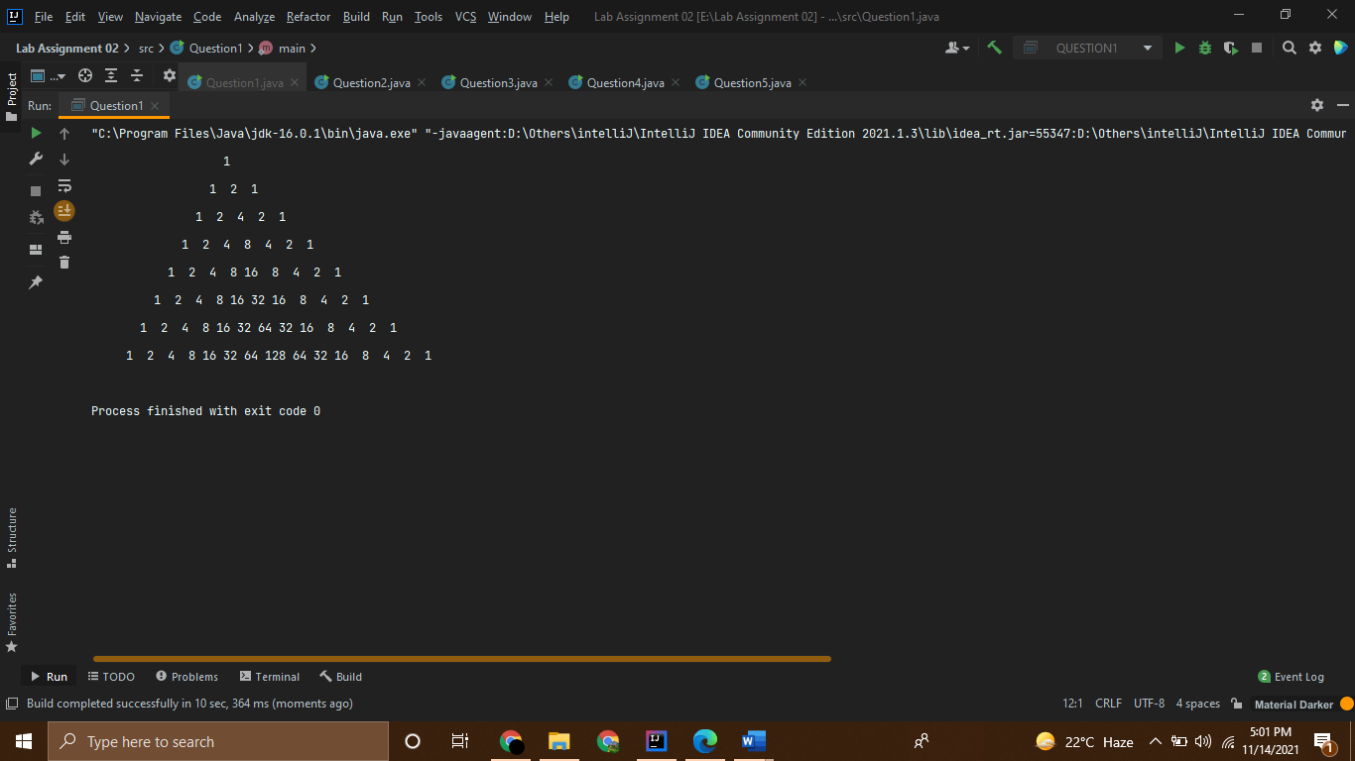

Question 2:

Source Code:

//------------------------------------------------------------

//----------------Shahzaneer Ahmed----------------------------

//////////////////SP21-BCS-087--------------------------------

//----------------Lab Assignment 02---------------------------

//------------------------------------------------------------

//Question – 2: ______

// Write a program that prompts the user to enter the year and first day of the year, and displays the first

// day of each month in the year. For example, if the user entered the year 2013, and 2 for Tuesday,

// January 1, 2013, your program should display the following output:

// January 1, 2013 is Tuesday

// ...

// December 1, 2013 is Sunday

import java.util.Scanner;

public class Question2 {

public static void main(String[] args){

Scanner input = new Scanner(System.in);

// Prompt the user to enter input

System.out.print("Enter a year: ");

int year = input.nextInt();

System.out.print("Enter the first day of the year: ");

int firstDay = input.nextInt();

int numberOfDaysInMonth = 0;

String firstDayString = "";

// Display calendar for each month

for (int month = 1; month <= 12; month++) {

// Display Calendar title

switch (month) {

case 1: System.out.print("January 1, " + year + " is ");

numberOfDaysInMonth = 31;

firstDayString = firstDay(firstDay);

System.out.println(firstDayString);

break;

case 2: System.out.print("February 1, " + year + " is ");

if (year % 400 == 0 || (year % 4 == 0 && year % 100 != 0))

numberOfDaysInMonth = 29;

else

numberOfDaysInMonth = 28;

firstDayString = firstDay(firstDay);

System.out.println(firstDayString);

break;

case 3: System.out.print("March 1, " + year + " is ");

numberOfDaysInMonth = 31;

firstDayString = firstDay(firstDay);

System.out.println(firstDayString);

break;

case 4: System.out.print("April 1, " + year + " is ");

numberOfDaysInMonth = 30;

firstDayString = firstDay(firstDay);

System.out.println(firstDayString);

break;

case 5: System.out.print("May 1, " + year + " is ");

numberOfDaysInMonth = 31;

firstDayString = firstDay(firstDay);

System.out.println(firstDayString);

break;

case 6: System.out.print("June 1, " + year + " is ");

numberOfDaysInMonth = 30;

firstDayString = firstDay(firstDay);

System.out.println(firstDayString);

break;

case 7: System.out.print("July 1, " + year + " is ");

numberOfDaysInMonth = 31;

firstDayString = firstDay(firstDay);

System.out.println(firstDayString);

break;

case 8: System.out.print("August 1, " + year + " is ");

numberOfDaysInMonth = 31;

firstDayString = firstDay(firstDay);

System.out.println(firstDayString);

break;

case 9: System.out.print("September 1, " + year + " is ");

numberOfDaysInMonth = 30;

firstDayString = firstDay(firstDay);

System.out.println(firstDayString);

break;

case 10: System.out.print("October 1, " + year + " is ");

numberOfDaysInMonth = 31;

firstDayString = firstDay(firstDay);

System.out.println(firstDayString);

break;

case 11: System.out.print("November 1, " + year + " is ");

numberOfDaysInMonth = 30;

firstDayString = firstDay(firstDay);

System.out.println(firstDayString);

break;

case 12: System.out.print("December 1, " + year + " is ");

numberOfDaysInMonth = 31;

firstDayString = firstDay(firstDay);

System.out.println(firstDayString);

break;

}

// Get the start day for the next month

firstDay = (firstDay + numberOfDaysInMonth) % 7;

}

}

public static String firstDay(int firstDay) {

String firstDayString = "";

switch (firstDay) {

case 0: firstDayString = "Sunday"; break;

case 1: firstDayString = "Monday"; break;

case 2: firstDayString = "Tuesday"; break;

case 3: firstDayString = "Wednesday"; break;

case 4: firstDayString = "Thursday"; break;

case 5: firstDayString = "Friday"; break;

case 6: firstDayString = "Saturday"; break;

}

return firstDayString;

}

}

Screenshot:

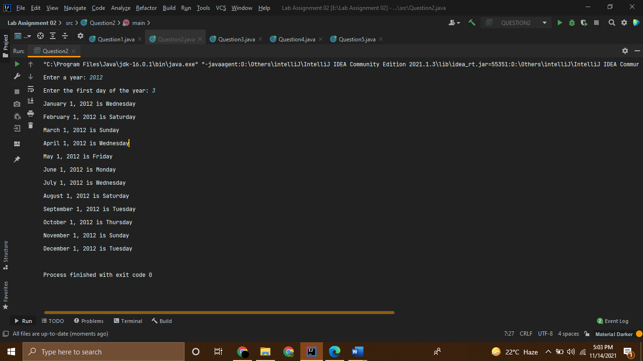

Question 3:

Source Code:

//------------------------------------------------------------

//----------------Shahzaneer Ahmed----------------------------

//////////////////SP21-BCS-087--------------------------------

//----------------Lab Assignment 02---------------------------

//------------------------------------------------------------

import java.util.Scanner;

public class Question3 {

public static void main(String...args){

Scanner sc = new Scanner(System.in);

System.out.print("Enter a word: ");

String str = sc.nextLine();

System.out.print(capatalize(str));

}

public static String capatalize(String lower_case_word){

String firstLetStr = lower_case_word.substring(0, 1);

String remLetStr = lower_case_word.substring(1);

firstLetStr = firstLetStr.toUpperCase();

String firstLetterCapitalizedName = firstLetStr + remLetStr;

String c = (firstLetterCapitalizedName);

return c;

}

}

Screenshot:

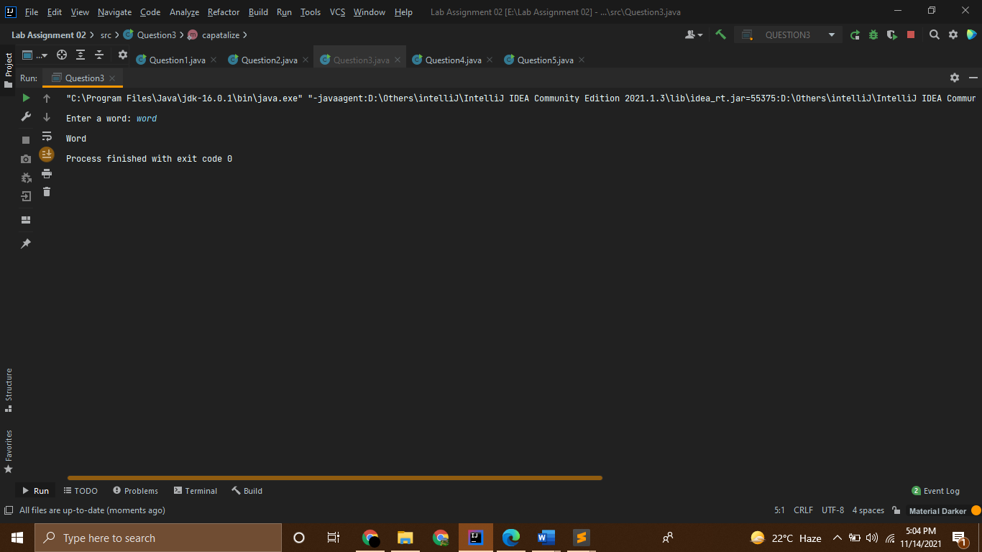

Question 4:

Source Code:

//------------------------------------------------------------

//----------------Shahzaneer Ahmed----------------------------

//////////////////SP21-BCS-087--------------------------------

//----------------Lab Assignment 02---------------------------

//------------------------------------------------------------

//Question – 4: ______

// Write a method that displays an n-by-n matrix using the following header: public static void

// printMatrix(int n)

// Each element is 0 or 1, which is generated randomly. Write a test program that prompts the user to

// enter n and displays an n-by-n matrix. Here is a sample run:

// Enter n: 3

// 0 1 0

// 0 0 0

// 1 1 1

import java.util.Scanner;

import java.util.Random;

public class Question4 {

public static void main(String[] args) {

Scanner input = new Scanner(System.in);

System.out.println("Enter the (n) the order of matrix :");

int order = input.nextInt();

printMatrix(order);

}

public static void printMatrix(int n){

Random rand = new Random();

for (int i = 0; i<n; i++){

for (int j = 0; j<n; j++){

int value = rand.nextInt(2);

System.out.print(value+" ");

}

System.out.println();

}

}

}

Screenshot:

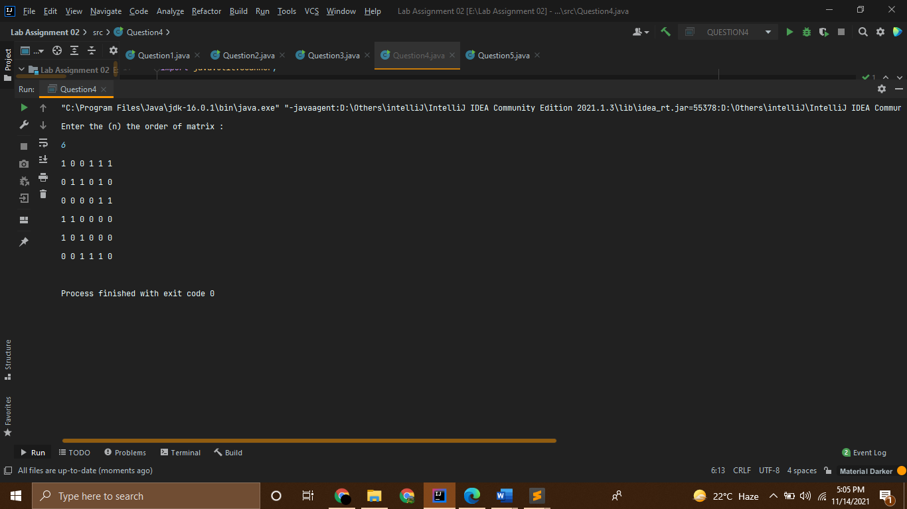

Question 5:

Source Code:

//------------------------------------------------------------

//----------------Shahzaneer Ahmed----------------------------

//////////////////SP21-BCS-087--------------------------------

//----------------Lab Assignment 02---------------------------

//------------------------------------------------------------

//Question – 5: ______

// The area of a pentagon can be computed using the following formula:

// Write a method that returns the area of a pentagon using the following header:

//public static double area(double side)

// Write a main method that prompts the user to enter the side of a pentagon and displays its area

// Sample Run

// Enter the side: 5.5

// The area of the pentagon is 52.0444413678162

import java.util.Scanner;

public class Question5 {

public static void main(String[] args) {

Scanner input = new Scanner(System.in);

System.out.println("Enter length of the side of a pentagon");

double side = input.nextDouble();

double AREA = area(side);

System.out.println(AREA);

}

public static double area(double side){

return ((5*(side*side))/(4*(Math.tan(Math.PI/5))));

}

}

Screenshot:

